Full Paper Format for ICLASS 2018 Meeting
A. B. Author^{1*}, C. D. Author²
¹Affiliation, University, Country
²Affiliation, University, Country

Abstract
Length of abstract is around 250 words. This is a nicely written abstract of the paper contents including scope, new experimental and/or modeling approaches and summary of major results. This is a nicely written abstract of the paper contents including scope, new experimental and/or modeling approaches and summary of major results. This is a nicely written abstract of the paper contents including scope, new experimental and/or modeling approaches and summary of major results. This is a nicely written abstract of the paper contents including scope, new experimental and/or modeling approaches and summary of major results. This is a nicely written abstract of the paper contents including scope, new experimental and/or modeling approaches and summary of major results. This is a nicely written abstract of the paper contents including scope, new experimental and/or modeling approaches and summary of major results. This is a nicely written abstract of the paper contents including scope, new experimental and/or modeling approaches and summary of major results.

Keywords: Spray, atomization, measurement, drop size, imaging diagnostics

Introduction
The total paper length should not exceed 8 pages and must not exceed 10 MB (pdf file). Please submit pdf file, not word or latex files. Please stick to the format and style of the present guideline. Figures should be included in the text (not summarized at the end) and numbered as they appear. Figures must be referenced in the text. The same applies to tables. References should be numbered in square brackets as they appear in the text. See examples in the section References. Equations should be centered and numbered, number in brackets with right alignment.
This is an excellent introduction into the topic of the paper. This is an excellent introduction into the topic of the paper. This is an excellent introduction into the topic of the paper. This is an excellent introduction into the topic of the paper. This is an excellent introduction into the topic of the paper. This is an excellent introduction into the topic of the paper. This is an excellent introduction into the topic of the paper. This is an excellent introduction into the topic of the paper. This is an excellent introduction into the topic of the paper. This is an excellent introduction into the topic of the paper. This is an excellent introduction into the topic of the paper. This is an excellent introduction into the topic of the paper.

Numerical and/or Experimental Methods
Here we find an excellent description of the methods used in the present study. Here we find an excellent description of the methods used in the present study.
Equation (1) gives the Lewis number

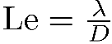 (1)
as the ratio of thermal and molecular diffusivities, λ and D, respectively, as an example for mathematical equations. Here we find an excellent description of the methods used in the present study. Here we find an excellent description of the methods used in the present study. Here we find an excellent description of the methods used in the present study. Here we find an excellent description of the methods used in the present study. Here we find an excellent description of the methods used in the present study. Here we find an excellent description of the methods used in the present study. Here we find an excellent description of the methods used in the present study. Here we find an excellent description of the methods used in the present study. Here we find an excellent description of the methods used in the present study. Here we find an excellent description of the methods used in the present study. Here we find an excellent description of the methods used in the present study.

Results and Discussion
Make sure you cite all references listed ‎[1], ‎[2], ‎[3]. Format see below. Format see below. Format see below. Format see below. Format see below. Format see below. Format see below. Format see below. Format see below. Format see below. Format see below. Format see below.
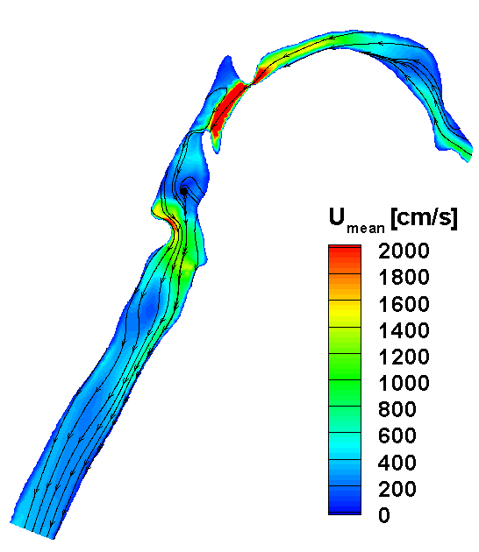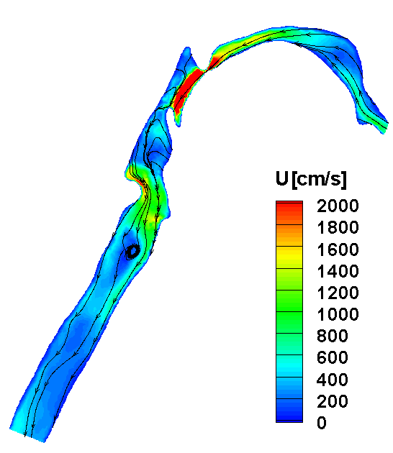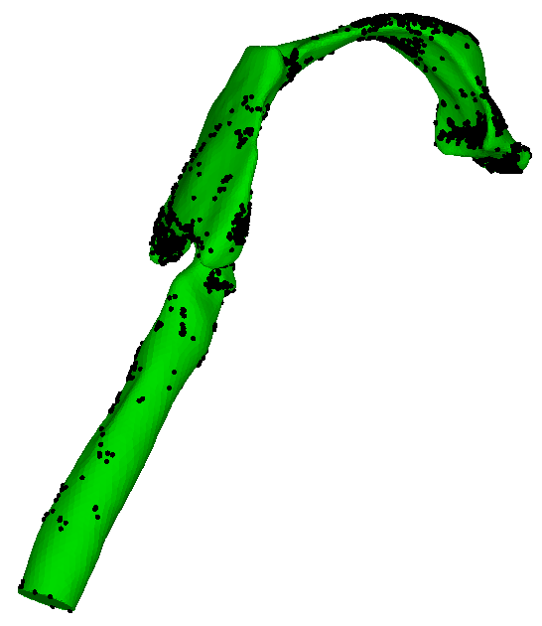
Figure 1 Time-averaged velocity contour plot and streamlines at the mid plane.

Figure 3 Deposition pattern of 2 μm sized particles on the surface of the mouth-throat model model.
Figure 2 Instant velocity contour plot and streamlines at the mid plane at t = 1.92228 s.
Figures 1, 2, and 3 show results of the study. They are discussed. They are discussed. They are discussed. They are discussed. They are discussed. They are discussed. They are discussed. They are discussed. They are discussed. They are discussed. They are discussed. They are discussed. They are discussed. They are discussed. They are discussed. They are discussed. They are discussed. They are discussed. They are discussed. They are discussed. They are discussed. They are discussed. They are discussed.

Summary and Conclusions
Here we find a nice summary, conclusions and possibly future work. Here we find a nice summary, conclusions and possibly future work. Here we find a nice summary, conclusions and possibly future work. Here we find a nice summary, conclusions and possibly future work. Here we find a nice summary, conclusions and possibly future work. Here we find a nice summary, conclusions and possibly future work. Here we find a nice summary, conclusions and possibly future work. Here we find a nice summary, conclusions and possibly future work. Here we find a nice summary, conclusions and possibly future work. Here we find a nice summary, conclusions and possibly future work. Here we find a nice summary, conclusions and possibly future work. Here we find a nice summary, conclusions and possibly future work. Here we find a nice summary, conclusions and possibly future work. Here we find a nice summary, conclusions and possibly future work.

Acknowledgements
Acknowledgements never hurt. Acknowledgements never hurt. Acknowledgements never hurt. Acknowledgements never hurt. Acknowledgements never hurt. Acknowledgements never hurt. Acknowledgements never hurt. Acknowledgements never hurt. Acknowledgements never hurt.

References
- Dukowicz, Journal of Computational Physics 2: 111-566 (1980)
- Bird, G. A., Molecular Gas Dynamics and Direct Simulation of Gas Flows, Oxford Science Publications 42, 1994.
- Ge, H.-W., Gutheil, E., Progress in Computational Fluid Dynamics 7-8: 467-472 (2007).
- Williams, F. A., Physics of Fluids 1: 541-545 (1958).
- Marchisio, D. L., Vigil, R. D., and Fox, R. O., Journal of Colloid and Interface Science 258-2: 322-334 (2003).
- Stieß, M., Mechanische Verfahrenstechnik - Partikeltechnologie 1, Berlin, Heidelberg: Springer, 2009.
- Marchisio, D. L. and Fox, R. O., Journal of Aerosol Science 36: 43-73 (2005).
- Fox, R. O., Laurent F., and Massot, M., Journal of Computational Physics 227-6: 3058-3088 (2008).
- Chan, T. L., Liu, Y. H., and Chan, C. K., Journal of Aerosol Science 41: 553-568 (2010).
- Selma, B., Bannari, R., and Proulx, P., Chemical Engineering Science 65-6: 1925-1941 (2010).
- Mezzei, L., Marchisio, L., and Lettieri, P., Industrial Engineering and Chemistry Research 49-11: 5141-5152 (2010).
- Bruyat, A., Laurent, C., and Rouzand, O., International Conference on Multiphase Flow, Tampa, Florida, May 30 - June 4, 2010.
- Fox, R. O., Industrial and Engineering Chemistry Research 48-21: 9686-9696 (2009).
- Abramzon, B., Sirignano, W. A., International Journal of Heat and Mass Transfer 32-9: 1605-1618 (1989).

